**4.AWS-VPC-Intra & Inter VPC Peering**

**1.Vpc peering Creating**

vpc peering is nothing but creating communication between the 2 VPC’S from different region or same region.

---IP range of each vpc must be different.

--- we can create up to 5 VPC’s at a time. You want to create more than 5 VPC’s, need to raise a request so AWS will provide you the access.

--- Both PPK and PEM files are private keys. We use Puttygen to create a public key.

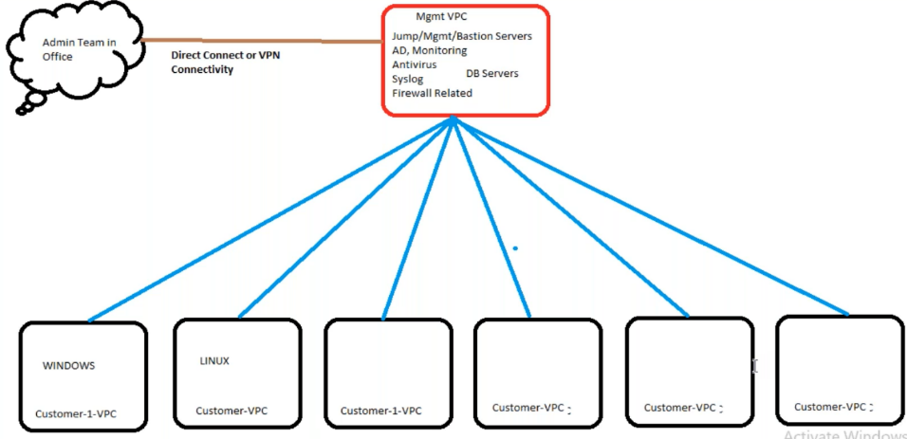

In this management VPC will communicate with other vpc.

**Importing key pair**

We need to import the key pair for the other regions, because if you maintaining different key pairs for the different regions it will be headache for you to maintain the key pairs.

This is where import kay pair option.

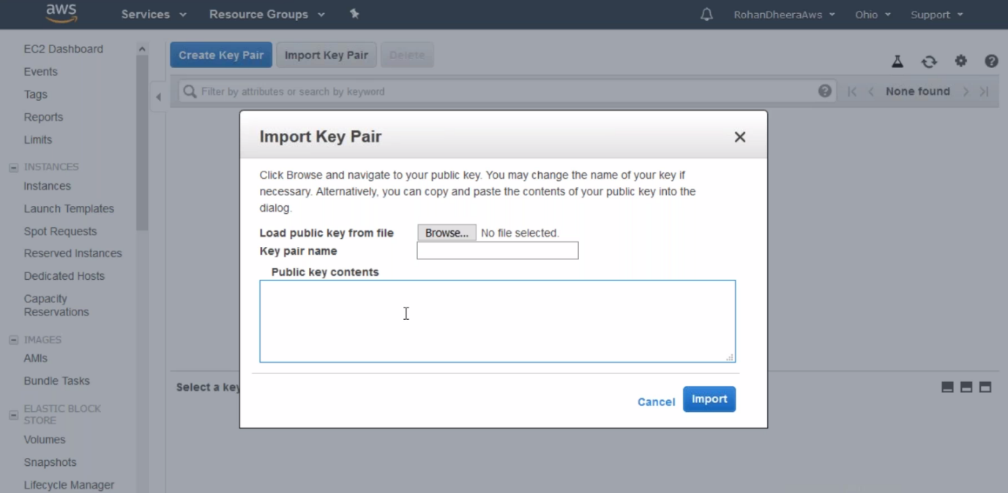

--- you need to paste below key pair.

--- **ec2-metadata** – type this on ec2 instance and you will get the key pair, paste it on above.

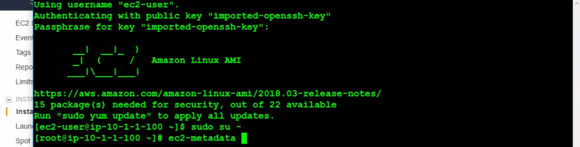

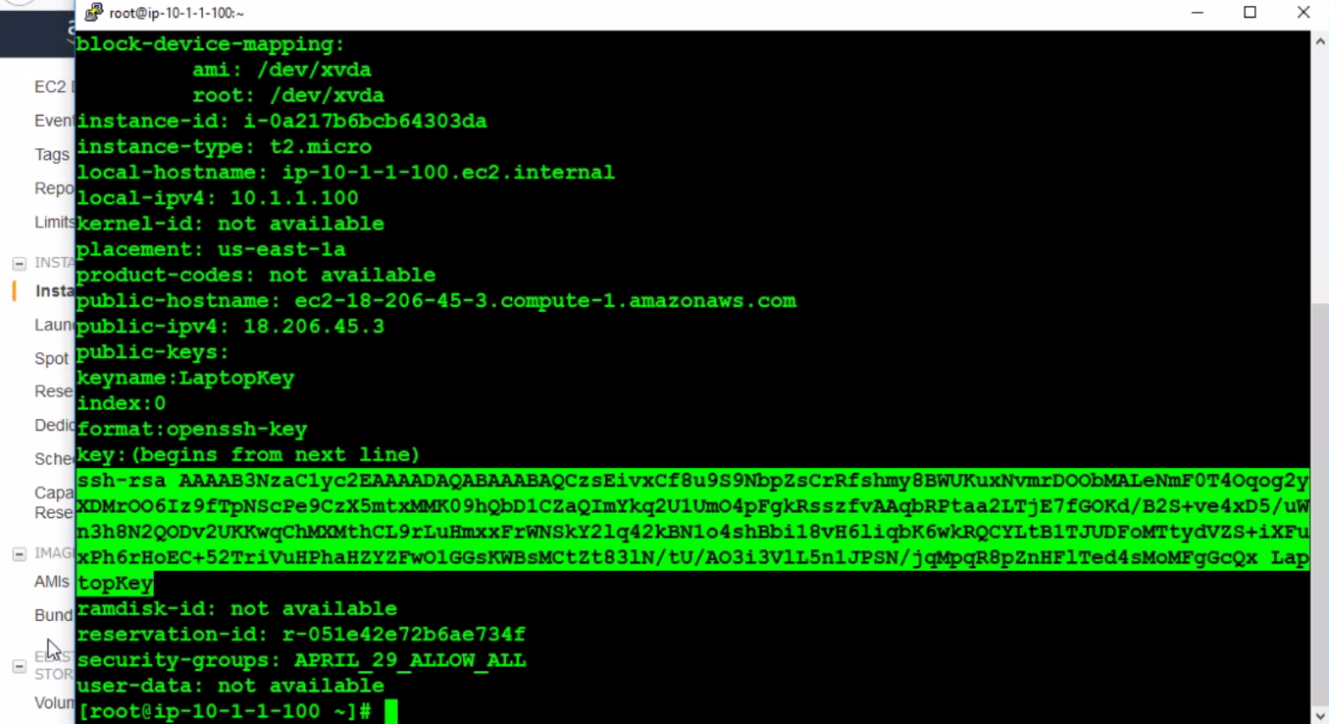

**Other way of getting this public key pair**

--- we can also create the public key pair using pem key.

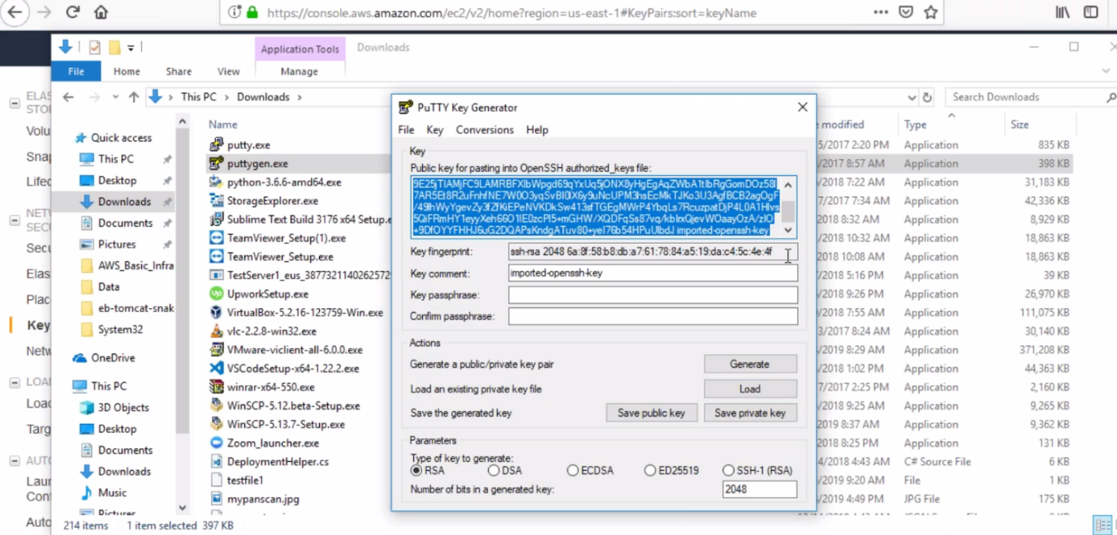

--- open puttygen.exe and load the pem file. You will get the public key

**Peering connection creating**

Two types of peering 1. inter vpc peering 2.intra vpc peering

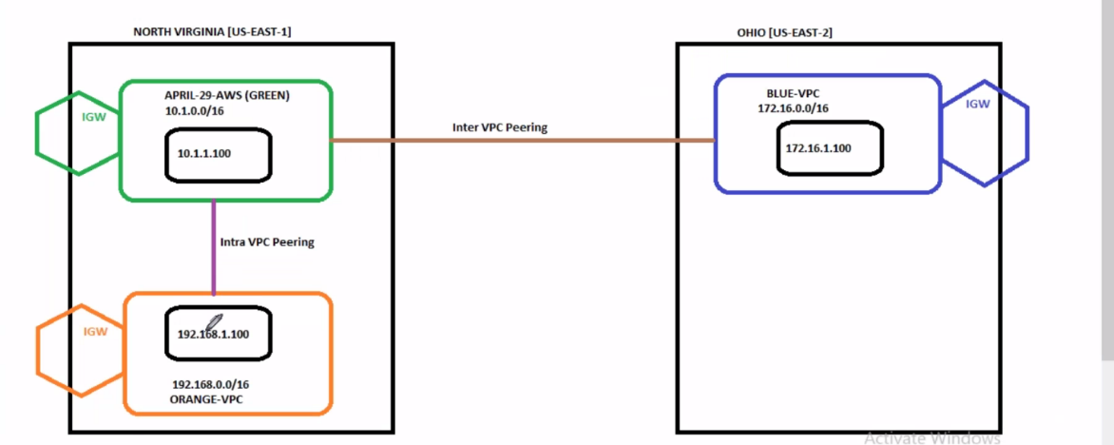

--- **private IP**– private **IP** is permeant

--- **public IP** – unlike private **IP** public IP is not permeant it will change if you stop the server.

**1.intra connection peering**

--- **intra connection** **peering** – connection between 2 VPC’s within region.

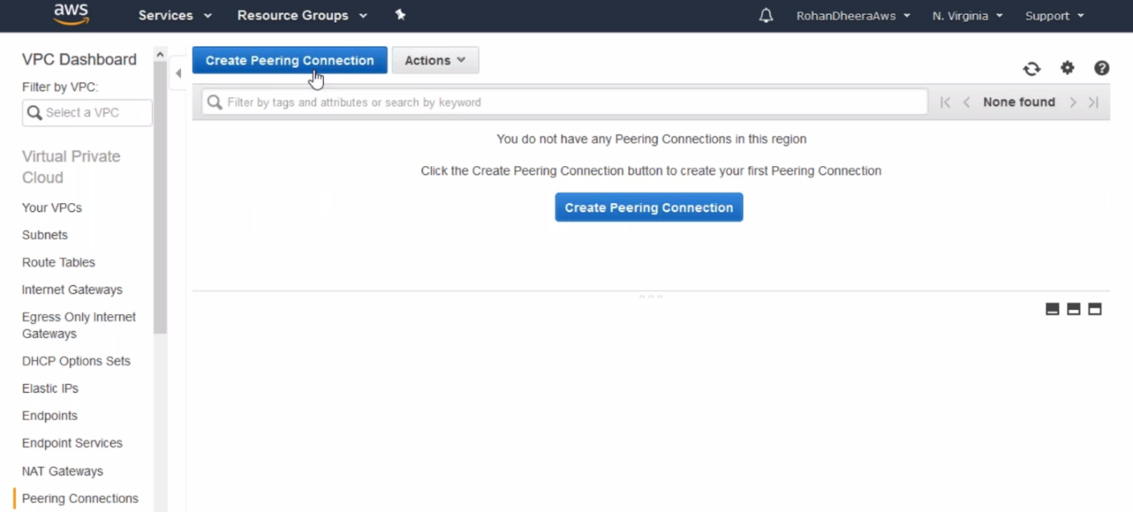

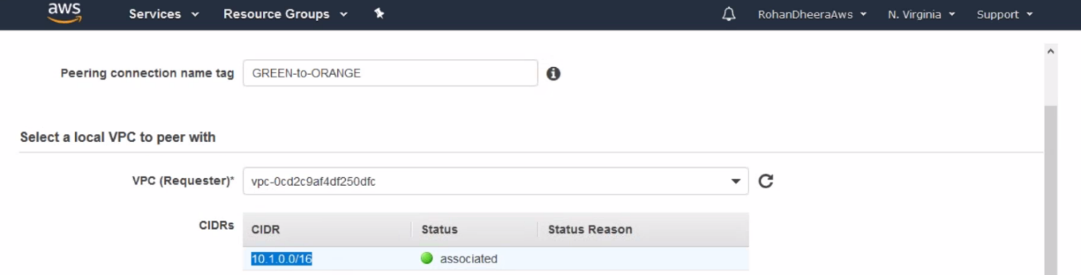

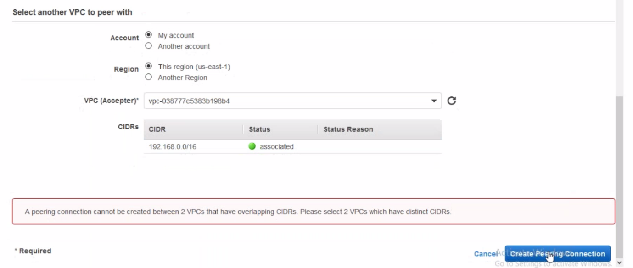

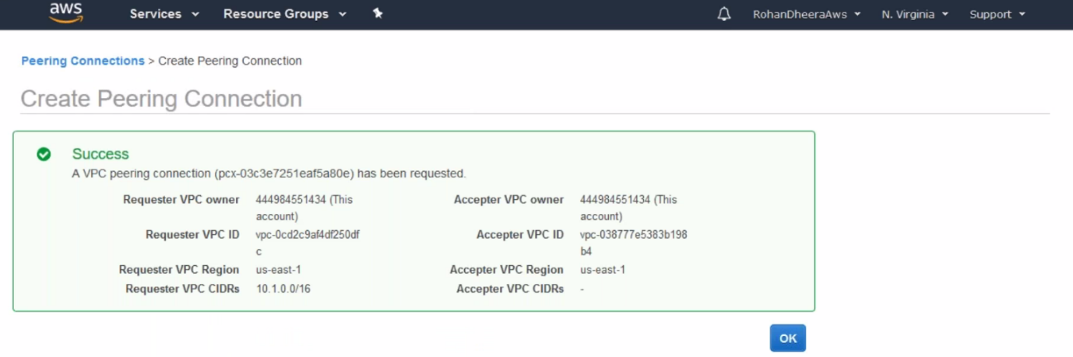

--- the peering connection is created successfully.

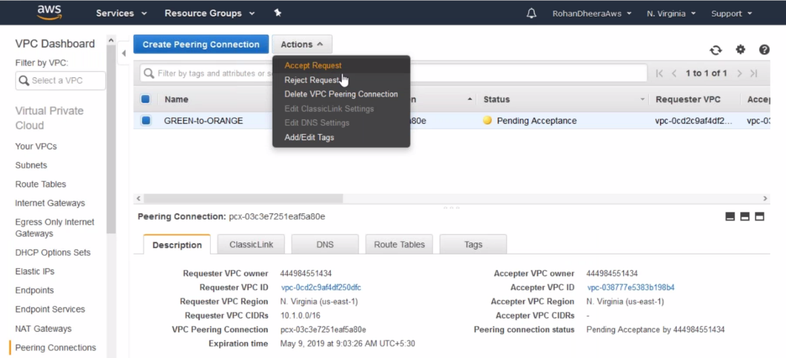

--- by default, the status of the peering connection is pending. We need to accept the request.

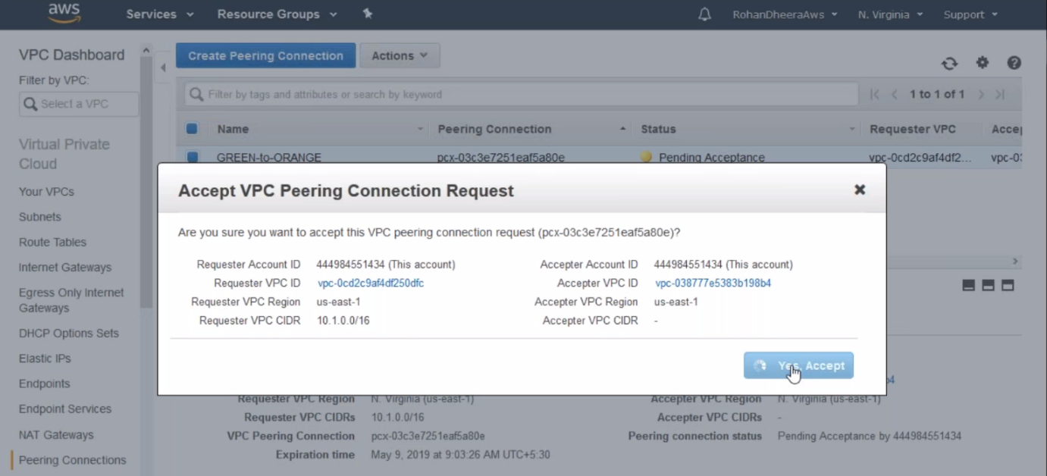

**Adding peering connections in routing table**

We have to mention the peering connection in routing table

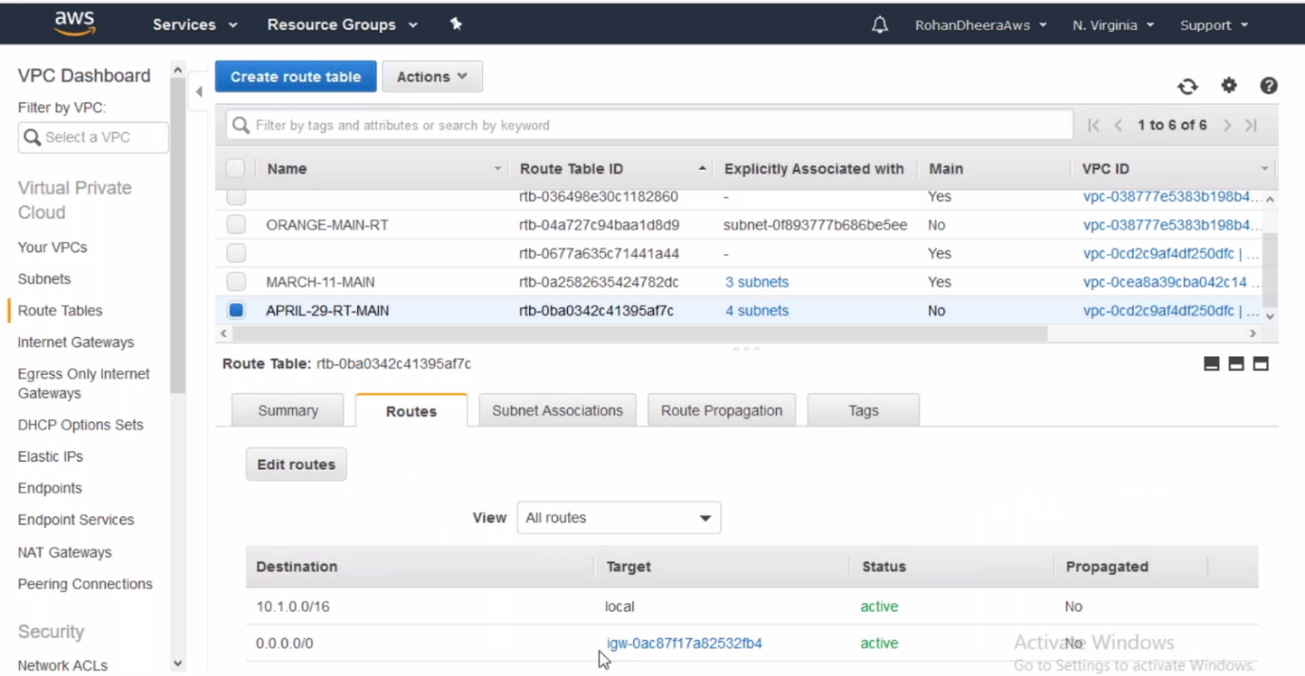

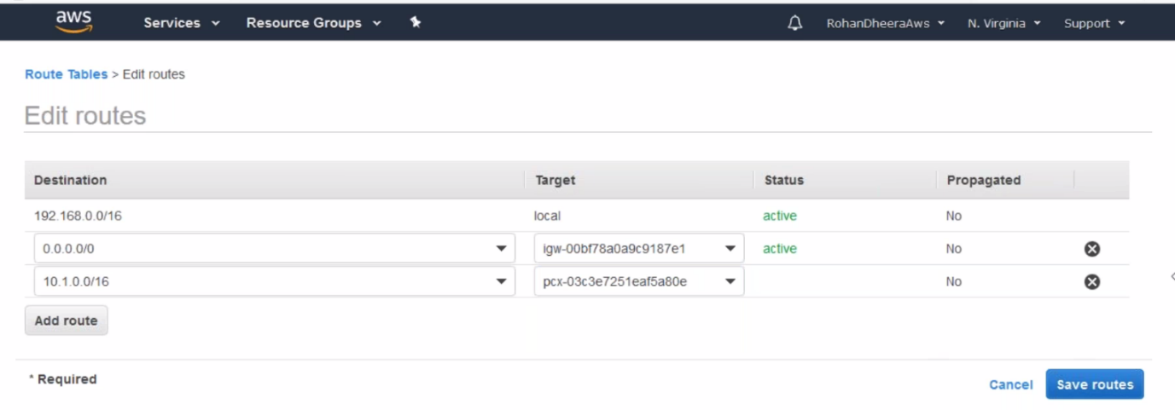

--- now the peering connection will be started

**2. inter connection peering**

connection between 2 VPC’s form different region

--- **inter connection** **peering** – connection between 2 VPC’s form different region.

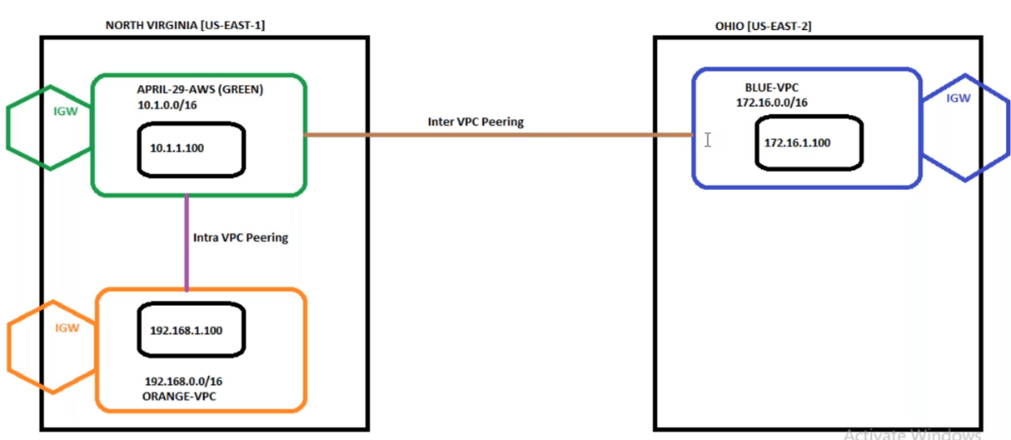

--- here we are creating peering connection between GREEN to BLUE

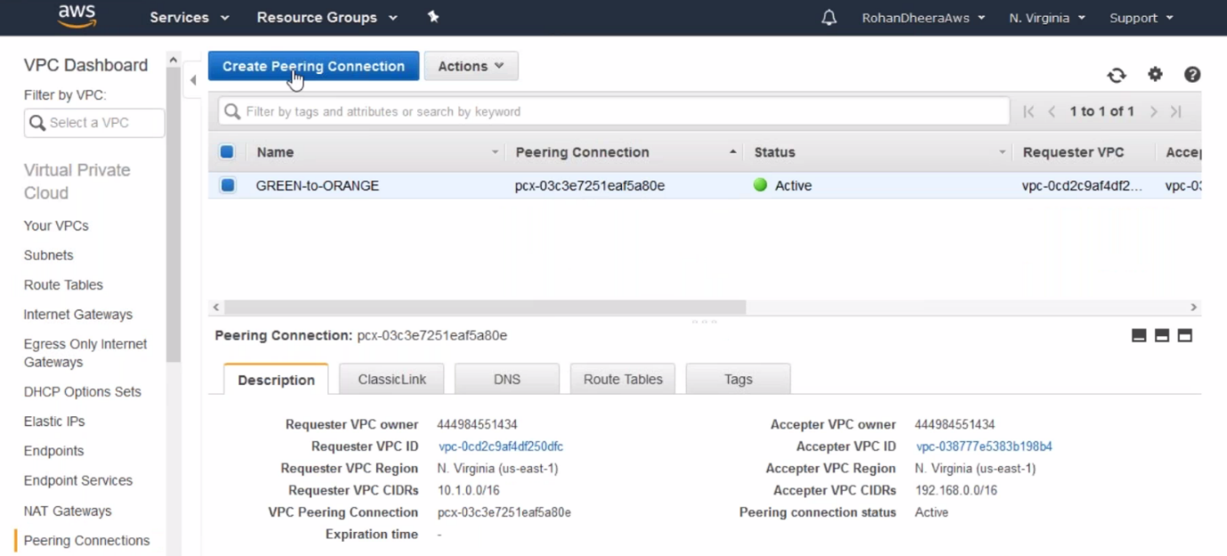

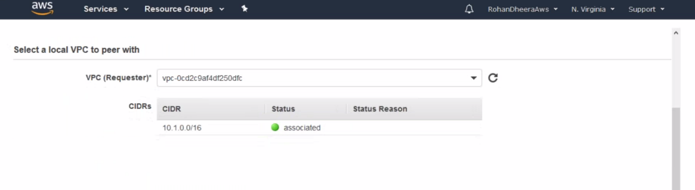

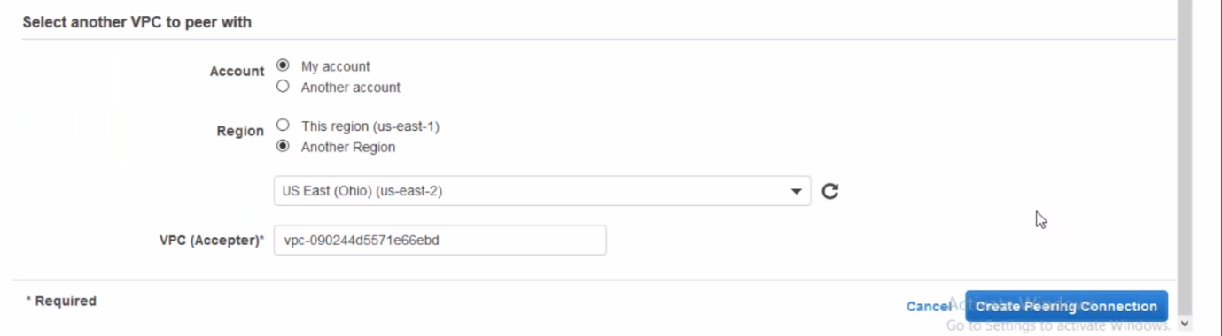

--- here we need to copy the VPC ID from another region and paste it.

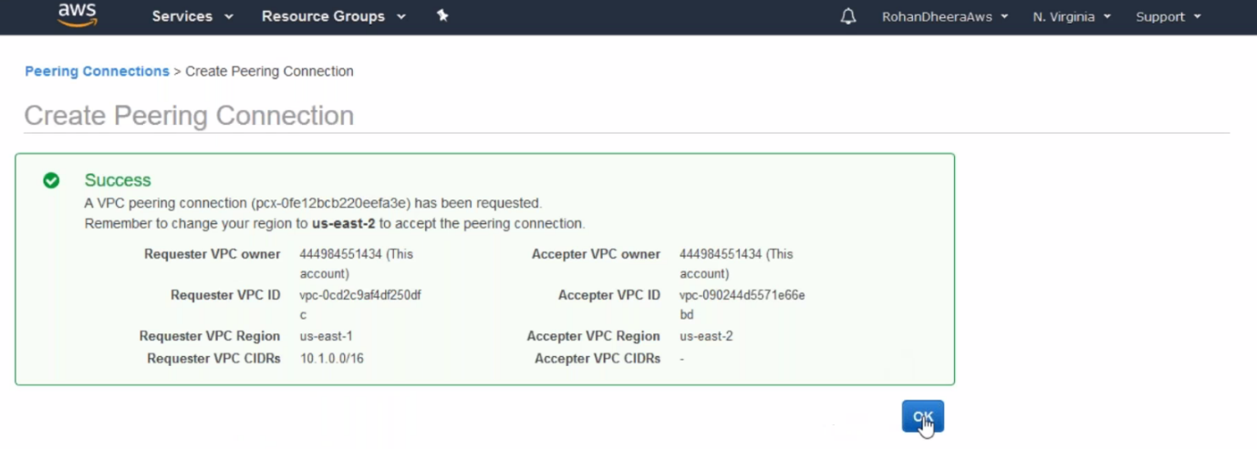

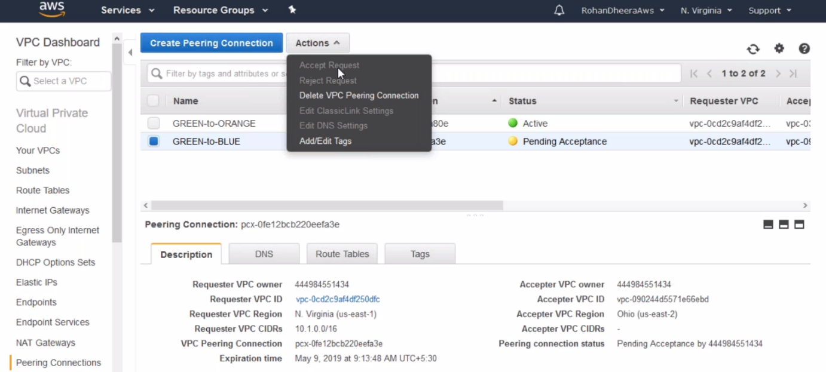

--- after creation of peering connection, the accepting request grey out. We need to go the other region and accept the request from there.

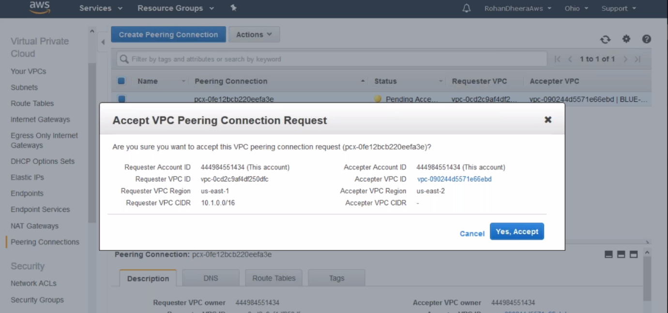

**Adding peering connections in routing table**

--- we are adding peering connection in routing table for blue vpc and same is done for other region green to orange vpc also.

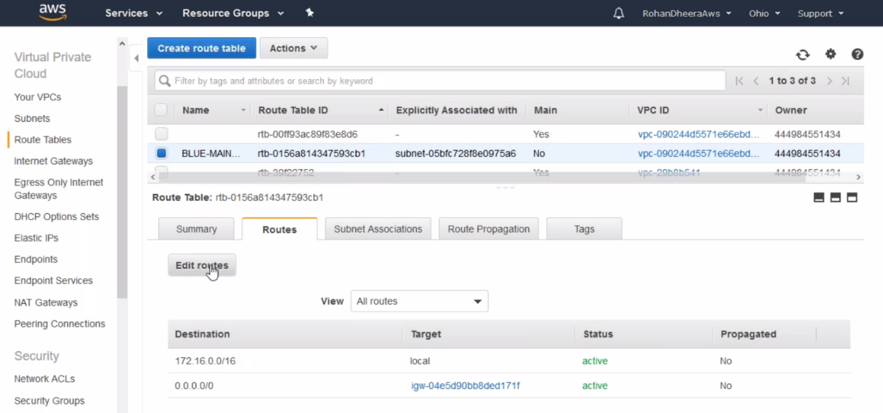

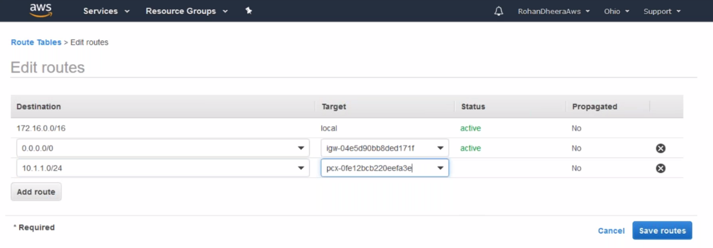

--- one side is created. Now go the other region vpc peering table and add peering connection in the routing table.

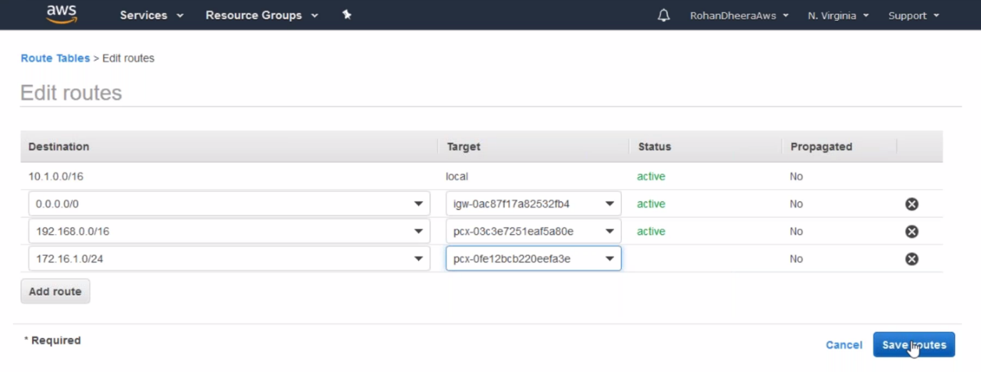

**Creating Peering connection from orange to green**

In this scenario we need to create a peering connection 1st.

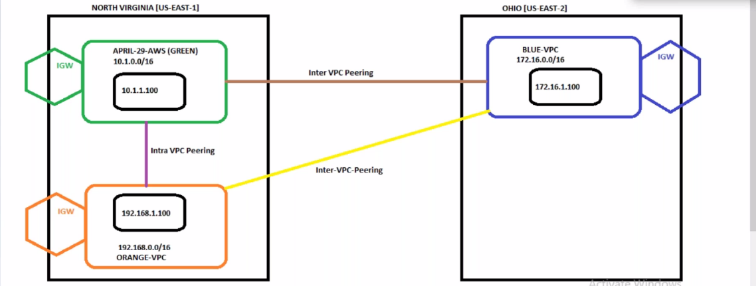

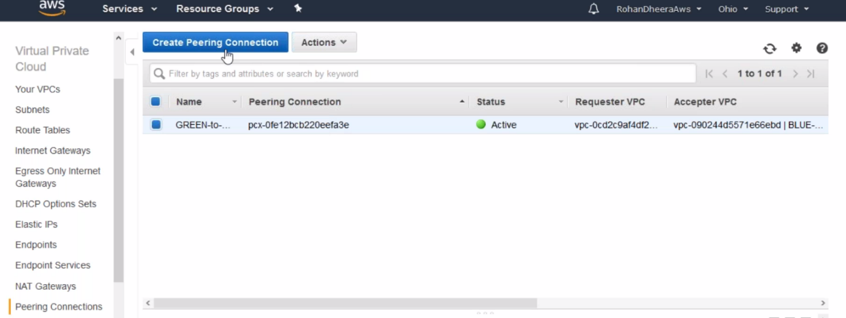

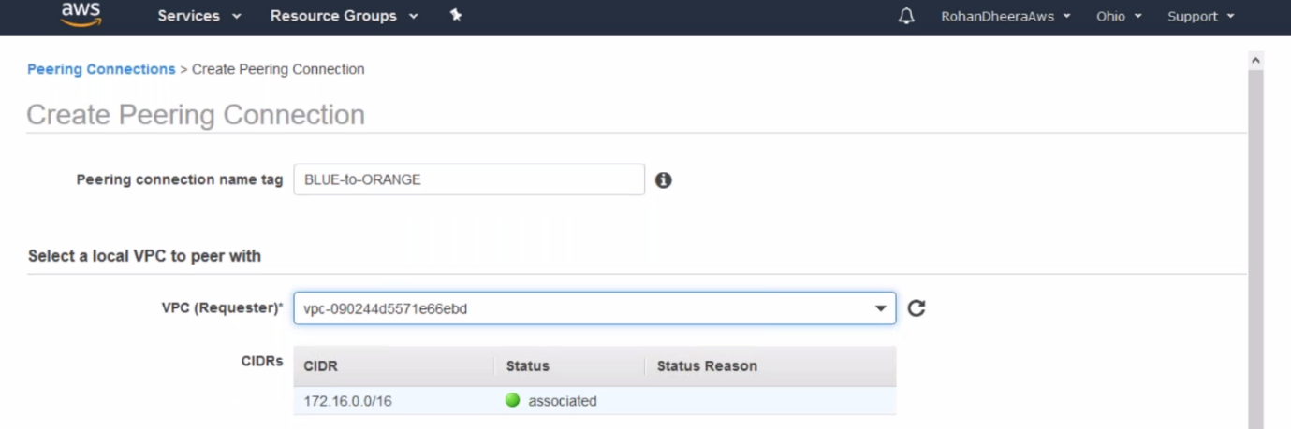

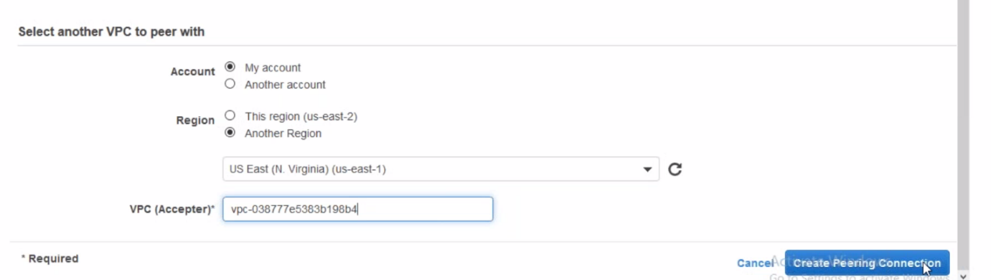

--- here we need to copy the other region VPC ID and paste it here.

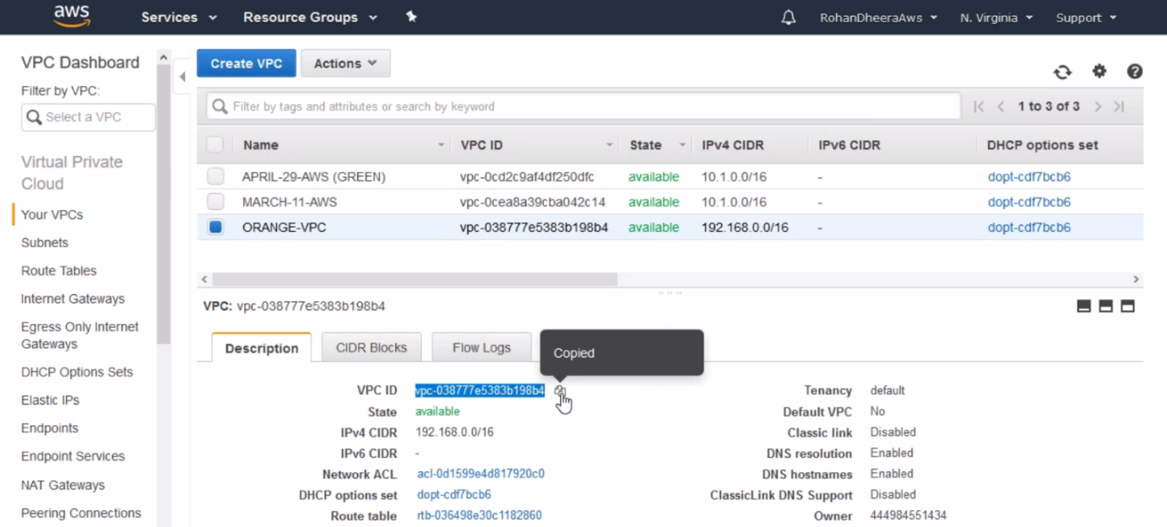

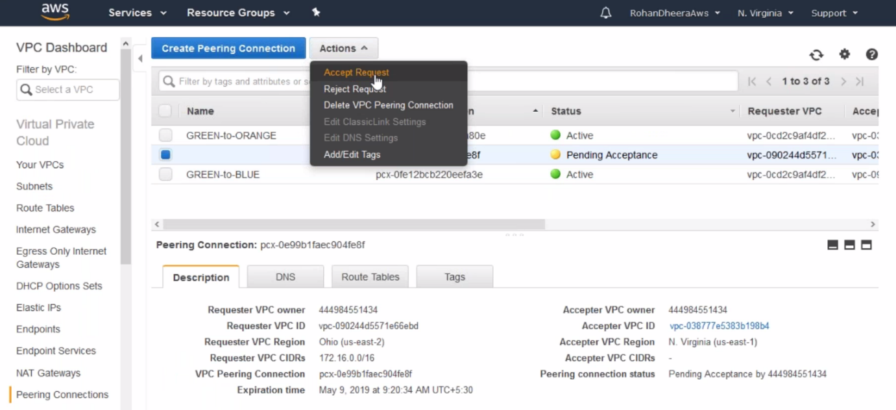

--- the peering connection sate is pending and we need to go the other vpc region and accept the request.



**Adding peering connections in routing table(orange)**

--- now go the orange vpc routing table and add peering connection.

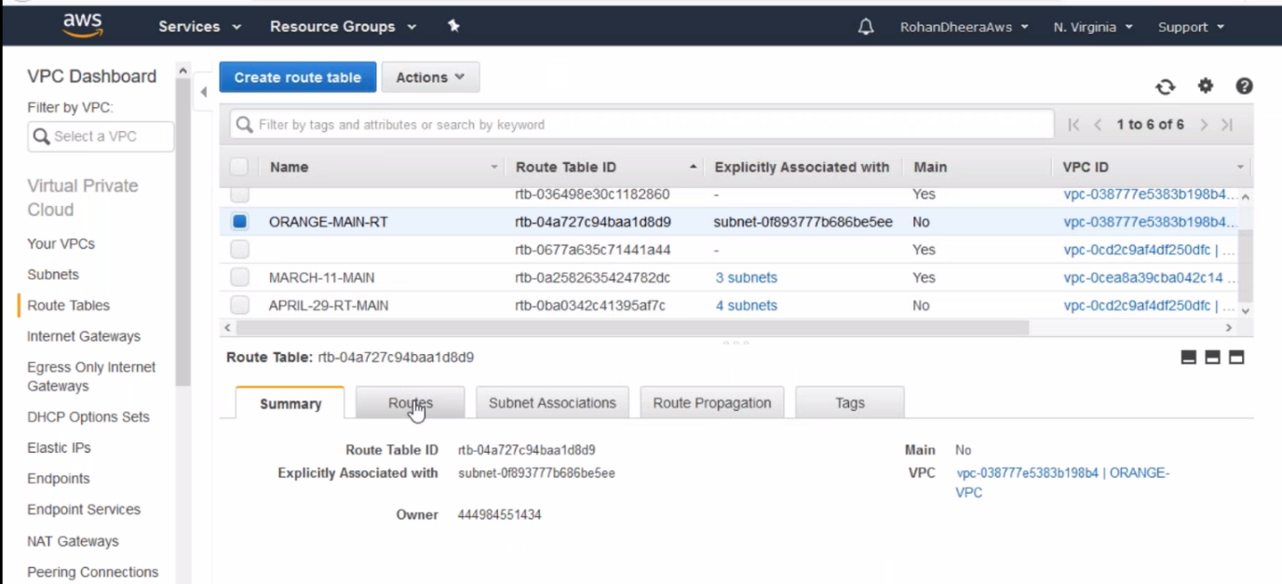

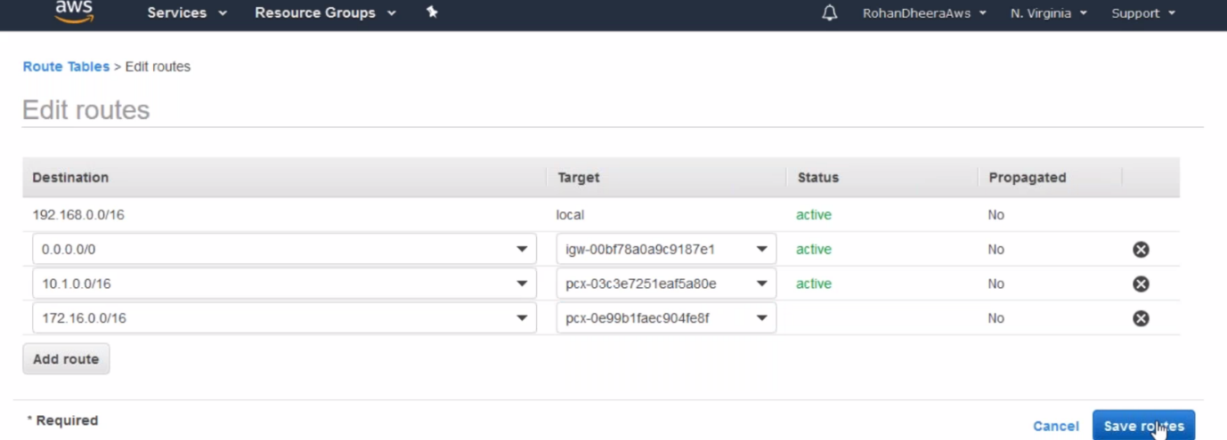

**Adding peering connections in routing table(blue)**

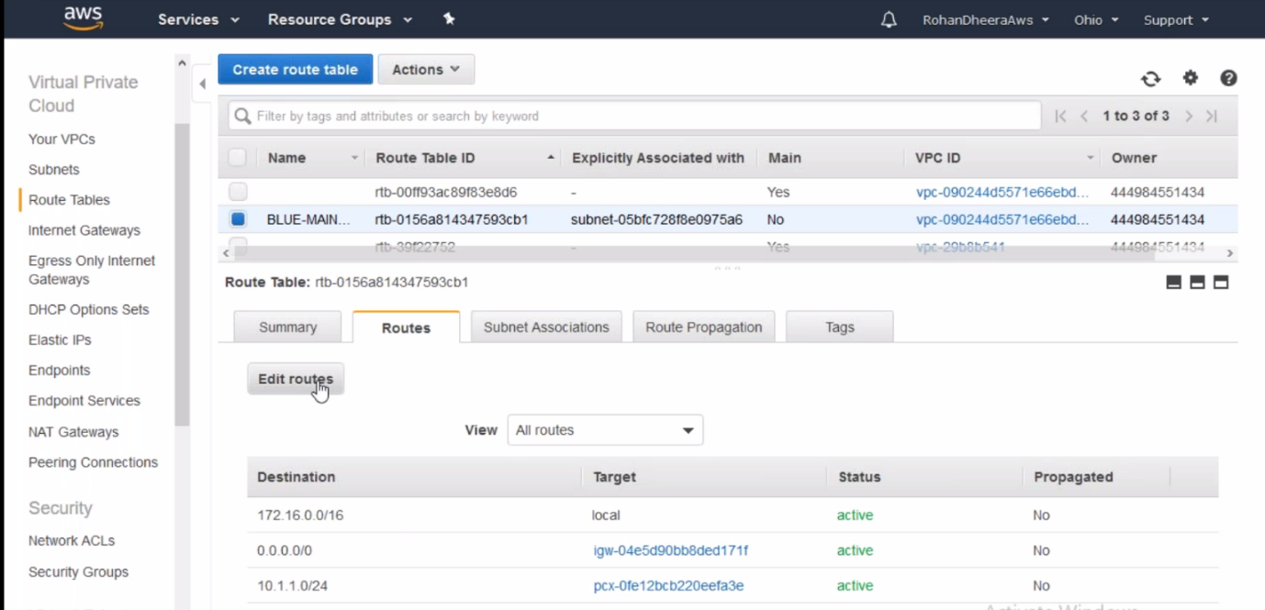

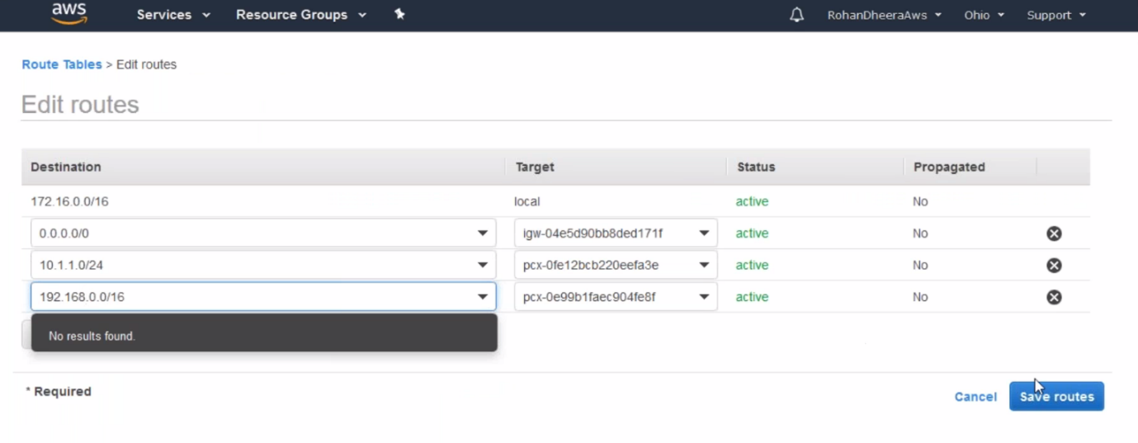

--- now the connection is established.

--- **QUES I created a vpc peering but the connection is greyout what shoud I do..?**

You are creating a peering connection between two regions so you have to go to the other region peering connection and accept the request there.

**Security groups ( In bound rules )**

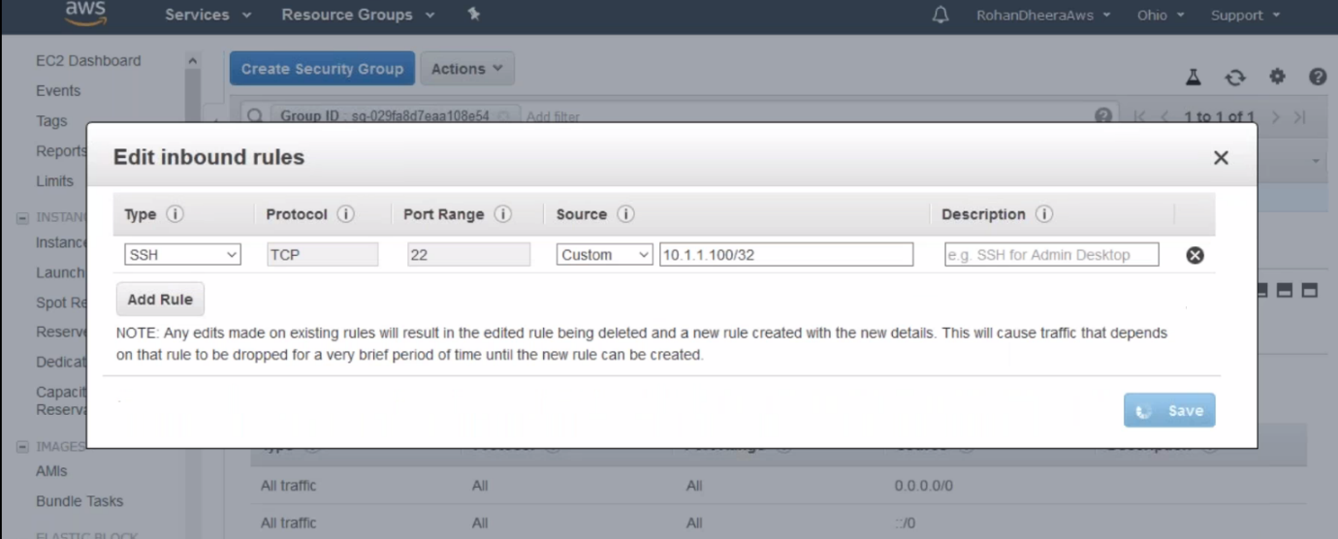

--- If we give like this, the instance will accept request from SSH. We can also mention IP address if you want to receive the traffic from particular IP address.